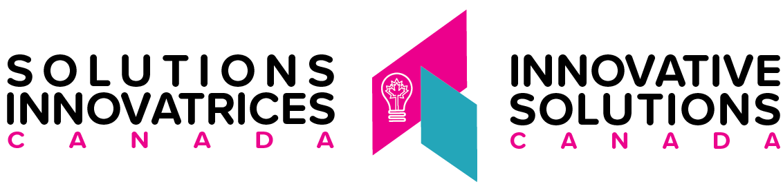

Innovative Solutions Canada (ISC) Program
Challenge Stream –Call for Proposals 003 -EN578-20ISC3
Amendment 001

This Amendment 001 is raised to modify the Challenge Stream - Call for Proposals 003 solicitation closing date as follows;

Update

The closing date for the Call for Proposals EN578-20ISC3 has been extended to June 30, 2022 at 2:00pm Eastern Standard Time (EST).

***** ALL OTHER TERMS AND CONDITIONS REMAIN THE SAME *****

